UNIT -1 : Introduction to Management

What Would You Do?
Like many students, maybe you’ve worked in the restaurant industry at some time or another. It’s not an easy job. It can be hot, dirty, and exhausting. Customers can be rude and demanding. And your work experiences, whether in a restaurant or in some other workplace, are likely to have been influenced by the skills and abilities of your manager. Lisa is a good example of what today’s successful managers are like and the skills they must have in dealing with the problems and challenges of managing in the twenty-first century. This book is about the important managerial work that Lisa and the millions of other managers like her do. The reality facing today’s managers is that the world has changed. In workplaces
of all types—restaurants, offices, retail stores, factories, and the like—managers must deal with changing expectations and new ways of managing employees and organizing work. In this chapter, we introduce you to managers and management by looking at why managers are important, who managers are and where they work, and what managers do. Finally, we wrap up the chapter by looking at the factors reshaping and redefining the manager’s job and discussing why it’s important to study management.

Why Are Managers Important?
“ . . . A great boss can change your life, inspiring you to new heights both professionally and personally, and energizing you and your team to together overcome new challenges bigger than any one of you could tackle alone.”2 If you’ve had the opportunity to work with a manager like this, count yourself lucky. Such a manager can make a job a lot more enjoyable and productive. However, even managers who don’t live up to such lofty ideals and expectations are important to organizations. Let’s look at three reasons why. The first reason managers are important is that organizations need their managerial skills
and abilities more than ever in these uncertain, complex, and chaotic times. As organizations deal with today’s challenges—the worldwide economic climate, changing technology, ever increasing globalization, and so forth—managers play an important role in identifying critical issues and crafting responses. For example, John Zapp, general manager of several car dealerships in Oklahoma City, has struggled to keep his businesses afloat and profitable in the current economic environment, just as many other car dealers have.3 However, after four decades in the car business, Zapp understands that he’s the one calling the shots and his “call” right now is to focus on selling more used cars. How? By keeping inventory moving and by keeping his salespeople engaged through small cash payment rewards for hitting sales goals. His skills and abilities as a manager have been crucial in guiding his organization through these challenging times. Another reason managers are important to organizations is that they’re critical to getting things done. For instance, in our chapter-opening story, Lisa wasn’t the person greeting and seating customers, taking their orders, cooking their meals, or preparing a table for another customer,
but she was the person who creates and coordinates the workplace systems and conditions so that others can perform those tasks. Although she often pitches in when and where needed, her job as manager is to ensure that all the employees are getting their jobs done so the organization can do what it’s in business to do. If work isn’t getting done or isn’t getting done as it should be, she’s also the one who must find out why and get things back on track. Finally, managers do matter to organizations! How do we know that? The Gallup Organization, which has polled millions of employees and tens of thousands of managers, has found that the single most important variable in employee productivity and loyalty isn’t pay or benefits or workplace environment; it’s the quality of the relationship between employees and their direct supervisors.4 In addition, global consulting firm Towers Watson found that the way a company manages and engages its people can significantly affect its financial performance.5 Also, a recent study of organizational performance found that managerial ability was important in creating organizational value.6 What can we conclude from such reports? That managers are important and they do matter!

Who Are Managers and Where Do They Work?
Managers may not be who or what you might expect! Managers can be under the age of 18 to over age 80. They run large corporations as well as entrepreneurial start-ups. They’re found in government departments, hospitals, small businesses, not-for-profit agencies, museums, schools, and even such nontraditional organizations as political campaigns and music tours. Managers can also be found doing managerial work in every country on the globe. In addition, some managers are top-level managers while others are first-line managers. And today, managers are just as likely to be women as they are men. However, the number of women in top-level manager positions remains low—only 27 women were CEOs of major U.S. corporations in 2010.8 But no matter where managers are found or what gender they are, the fact is . . . managers have exciting and challenging jobs!

Who Is a Manager?
It used to be fairly simple to define who managers were: They were the organizational members who told others what to do and how to do it. It was easy to differentiate managers from nonmanagerial employees. Now, it isn’t quite that simple. In many organizations, the changing nature of work has blurred the distinction between managers and nonmanagerial employees. Many traditional nonmanagerial jobs now include managerial activities.9 For example, at General Cable Corporation’s facility in Moose Jaw, Saskatchewan, Canada, managerial responsibilities are shared by managers and team members. Most of the employees at Moose Jaw are cross-trained and multi-skilled. Within a single shift, an employee can be a team leader, equipment operator, maintenance technician, quality inspector, or improvement Planner.

So, how do we define who managers are? A manager is someone who coordinates and oversees the work of other people so that organizational goals can be accomplished. A manager’s job is not about personal achievement—it’s about helping others do their work. That may mean coordinating the work of a departmental group, or it might mean supervising a single person. It could involve coordinating the work activities of a team with people from different departments or even people outside the organization, such as temporary employees or individuals who work for the organization’s suppliers. Keep in mind, also, that managers may have work duties not related to coordinating and overseeing others’ work. For example, an insurance claims supervisor might process claims in addition to coordinating the work activities of other claims clerks. Is there a way to classify managers in organizations? In traditionally structured organizations (which are often pictured as a pyramid because more employees are at lower organizational levels than at upper organizational levels), managers can be classified as first-line, middle, or top. (See Exhibit 1-1.)

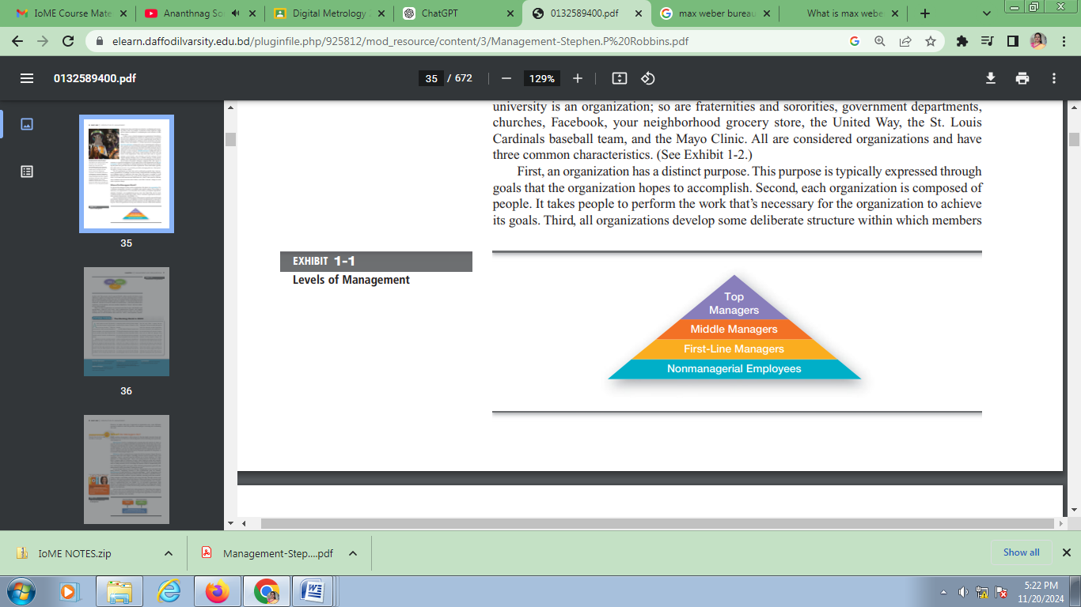
At the lowest level of management, first-line managers manage the work of nonmanagerial employees who typically are involved with producing the organization’s products or servicing the organization’s customers. First-line managers may be called supervisors or even shift managers, district managers, department managers, or office managers. Middle managers manage the work of first-line managers and can be found between the lowest and top levels of the organization. They may have titles such as regional manager, project leader, store manager, or division manager. In our chapter-opening dilemma, Lisa is a middle manager. As the general manager, she’s responsible for how her restaurant performs, but also is one of about 60 general managers company-wide who report to someone at corporate headquarters. At the upper levels of the organization are the top managers, who are responsible for making organization-wide decisions and establishing the plans and goals that affect the entire organization. These individuals typically have titles such as executive vice president, president, managing director, chief operating officer, or chief executive officer.

Not all organizations get work done with a traditional pyramidal form, however. Some organizations, for example, are more loosely configured with work being done by ever-changing teams of employees who move from one project to another as work demands arise. Although it’s not as easy to tell who the anagers are in these organizations, we do know that someone must fulfill that role—that is, there must be someone who coordinates and oversees the work of others, even if that “someone” changes as work tasks or projects change.

Where Do Managers Work?
It’s obvious that managers do their work in organizations. But what is an organization? It’s a deliberate arrangement of people to accomplish some specific purpose. Your college or university is an organization; so are fraternities and sororities, government departments, churches, Facebook, your neighborhood grocery store, the United Way, the St. Louis Cardinals baseball team, and the Mayo Clinic. All are considered organizations and have three common characteristics. (See Exhibit 1-2.)

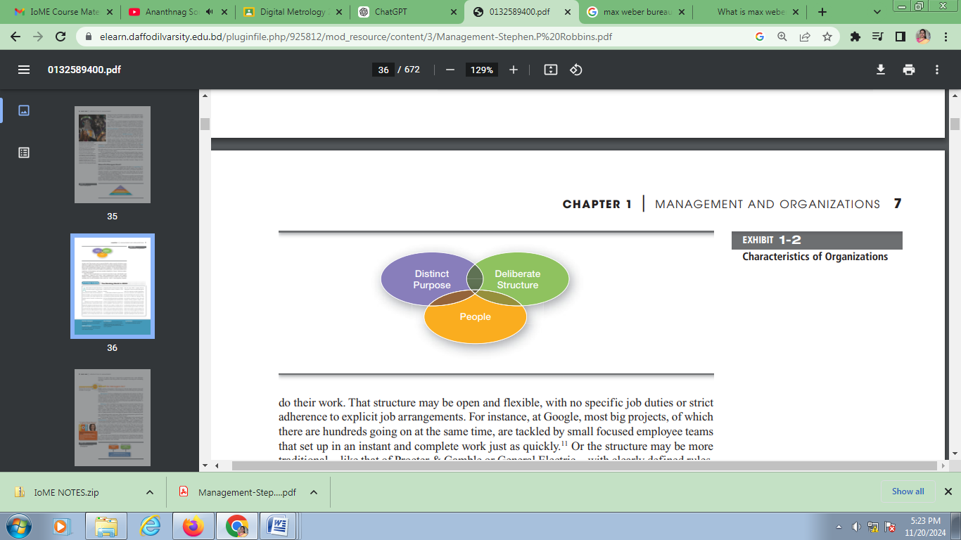

First, an organization has a distinct purpose. This purpose is typically expressed through goals that the organization hopes to accomplish. Second, each organization is composed of people. It takes people to perform the work that’s necessary for the organization to achieve its goals. Third, all organizations develop some deliberate structure within which members do their work. That structure may be open and flexible, with no specific job duties or strict adherence to explicit job arrangements. For instance, at Google, most big projects, of which there are hundreds going on at the same time, are tackled by small focused employee teams that set up in an instant and complete work just as quickly.11 Or the structure may be more traditional—like that of Procter & Gamble or General Electric—with clearly defined rules, regulations, job descriptions, and some members identified as “bosses” who have authority over other members. Many of today’s organizations are structured more like Google, with flexible work arrangements, employee work teams, open communication systems, and supplier alliances. In these organizations, work is defined in terms of tasks to be done. And workdays have no time boundaries since work can—and is—done anywhere, anytime.

What Do Managers Do?
Simply speaking, management is what managers do. But that simple statement doesn’t tell us much, does it? Let’s look first at what management is before discussing more specifically what managers do.

Management involves coordinating and overseeing the work activities of others so that their activities are completed efficiently and effectively. We already know that coordinating and overseeing the work of others is what distinguishes a managerial position from a nonmanagerial one. However, this doesn’t mean that managers can do what they want anytime, anywhere, or in any way. Instead, management involves ensuring that work activities are completed efficiently and effectively by the people responsible for doing them, or at least that’s what managers aspire to do.

Efficiency refers to getting the most output from the least amount of inputs. Because managers deal with scarce inputs—including resources such as people, money, and equipment—they’re concerned with the efficient use of those resources. It’s often referred to as “doing things right”—that is, not wasting resources. For instance, at the HON Company plant in Cedartown, Georgia, where employees make and assemble office furniture, efficient manufacturing techniques were implemented by doing things such as cutting inventory levels, decreasing the amount of time to manufacture products, and lowering product reject rates. These efficient work practices paid off as the plant reduced costs by more than $7 million in one year.13 It’s not enough, however, just to be efficient. Management is also concerned with being effective, completing activities so that organizational goals are attained.

Effectiveness is often described as “doing the right things”—that is, doing those work activities that will help the organization reach its goals. For instance, at the HON factory, goals included meeting customers’ rigorous demands, executing world-class manufacturing strategies, and making employee jobs easier and safer. Through various work initiatives, these goals were pursued and achieved. Whereas efficiency is concerned with the means of getting things done, effectiveness is concerned with the ends, or attainment of organizational goals (see Exhibit 1-3).

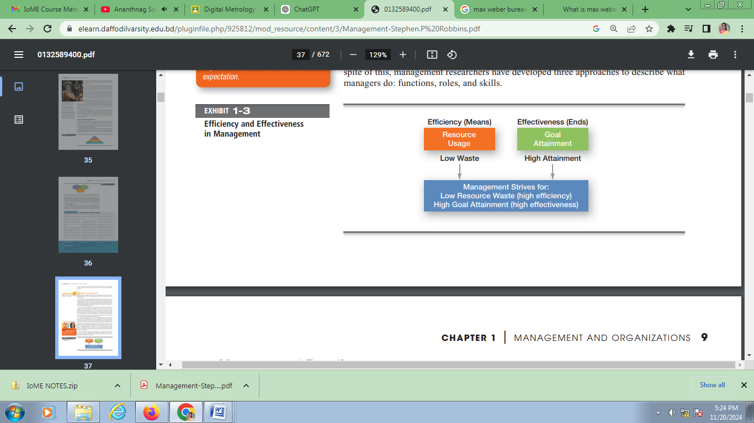
In successful organizations, high efficiency and high effectiveness typically go hand in hand. Poor management (which leads to poor performance) usually involves being inefficient and ineffective or being effective, but inefficient. Now let’s take a more detailed look at what managers do. Describing what managers do isn’t easy. Just as no two organizations are alike, no two managers’ jobs are alike. In spite of this, management researchers have developed three approaches to describe what managers do: functions, roles, and skills.

Management Functions: POSDCORB
The term POSDCORB represents a framework for the core functions of management, introduced by Luther Gulick and Lyndall Urwick in 1937. It provides a systematic approach to managerial activities and serves as a checklist for managers to ensure efficient organizational operations.

What Does POSDCORB Stand For?
POSDCORB is an acronym that breaks down managerial functions into seven key activities:
- Planning
- Organizing
- Staffing
- Directing
- Coordinating
- Reporting
- Budgeting
Let’s delve into each function in detail:

1. Planning
Planning involves deciding in advance what to do, how to do it, when to do it, and who will do it. It sets the foundation for all other managerial activities.
Key Features of Planning:
- Establishing objectives and goals.
- Determining strategies to achieve them.
- Forecasting future conditions.
- Preparing action plans.
Example: A manager plans a new marketing strategy for launching a product in a competitive market.

2. Organizing
Organizing is about creating a structure within the organization to execute the plans effectively. It involves allocating resources, assigning tasks, and defining roles and responsibilities.
Key Features of Organizing:
- Designing the organizational structure.
- Grouping similar tasks into departments.
- Delegating authority and responsibilities.
- Establishing relationships between individuals and departments.
Example: Setting up a team structure for a project with defined roles like team leader, designers, and developers.

3. Staffing
Staffing refers to recruiting, selecting, training, and retaining the right personnel for the right jobs. It ensures the organization has skilled employees to meet its objectives.
Key Features of Staffing:
- Job analysis and workforce planning.
- Recruitment and selection processes.
- Training and development.
- Employee motivation and performance evaluation.
Example: Conducting interviews and onboarding new employees for an expanding sales team.

4. Directing
Directing focuses on guiding, motivating, and leading the employees to achieve organizational goals. It emphasizes human interaction and communication.
Key Features of Directing:
- Providing instructions and guidance.
- Motivating employees through incentives.
- Resolving conflicts and maintaining discipline.
- Leadership and supervision.
Example: A manager motivates their team by recognizing high-performing employees in team meetings.

5. Coordinating
Coordinating ensures that the efforts of various departments and employees are aligned with organizational goals. It involves harmonizing activities to avoid duplication or conflict.
Key Features of Coordinating:
- Integrating individual and departmental goals.
- Ensuring smooth workflows and communication.
- Maintaining inter-departmental collaboration.
Example: Ensuring that the production team and the logistics team work together to deliver products on time.

6. Reporting
Reporting involves keeping stakeholders informed about the organization's performance and progress. It includes collecting, analyzing, and sharing information.
Key Features of Reporting:
- Creating periodic reports for internal and external use.
- Communicating performance metrics to management.
- Providing transparency and accountability.
Example: Preparing a quarterly sales report and presenting it to the board of directors.

7. Budgeting
Budgeting refers to planning, allocating, and controlling the organization's financial resources. It ensures that all activities are financially sustainable.
Key Features of Budgeting:
- Estimating revenues and expenses.
- Allocating funds to various departments.
- Monitoring and controlling expenditures.
- Adjusting financial plans as needed.
Example: Preparing an annual budget for a marketing campaign, including costs for advertisements, events, and promotions.

Mintzberg’s Managerial Roles and a Contemporary Model of Managing

Henry Mintzberg, a well-known management researcher, studied actual managers at work. In his first comprehensive study, Mintzberg concluded that what managers do can best be described by looking at the managerial roles they engage in at work.16 The term managerial roles refers to specific actions or behaviors expected of and exhibited by a manager. (Think of the different roles you play—such as student, employee, student organization member, volunteer, sibling, and so forth—and the different things you’re expected to do in these roles.) When describing what managers do from a roles perspective, we’re not looking at a specific person per se, but at the expectations and responsibilities that are associated with being the person in that role—the role of a manager. As shown in Exhibit 1-5, these 10 roles are grouped around interpersonal relationships, the transfer of information, and decision making. The interpersonal roles are ones that involve people (subordinates and persons outside the organization) and other duties that are ceremonial and symbolic in nature. The three interpersonal roles include figurehead, leader, and liaison. The informational roles involve collecting, receiving, and disseminating information. The three informational roles include monitor, disseminator, and spokesperson. Finally, the decisional roles entail making decisions or choices. The four decisional roles include entrepreneur, disturbance handler, resource allocator, and negotiator.

As managers perform these roles, Mintzberg proposed that their activities included both reflection (thinking) and action (doing).18 Our manager in the chapter opener would do both as she manages. For instance, reflection would occur when Lisa listens to employees’ or customers’ problems, while action would occur when she resolves those problems.

Management Skills

Dell Inc. is a company that understands the importance of management skills.24 It started an intensive five-day offsite skills training program for first-line managers as a way to improve its operations. One of Dell’s directors of learning and development thought this was the best way to develop “leaders who can build that strong relationship with their front-line employees.” What have the supervisors learned from the skills training? Some things they mentioned were how to communicate more effectively and how to refrain from jumping to conclusions when discussing a problem with a worker. What types of skills do managers need? Robert L. Katz proposed that managers need three critical skills in managing: technical, human, and conceptual.25 (Exhibit 1-6 shows the relationships of these skills to managerial levels.)
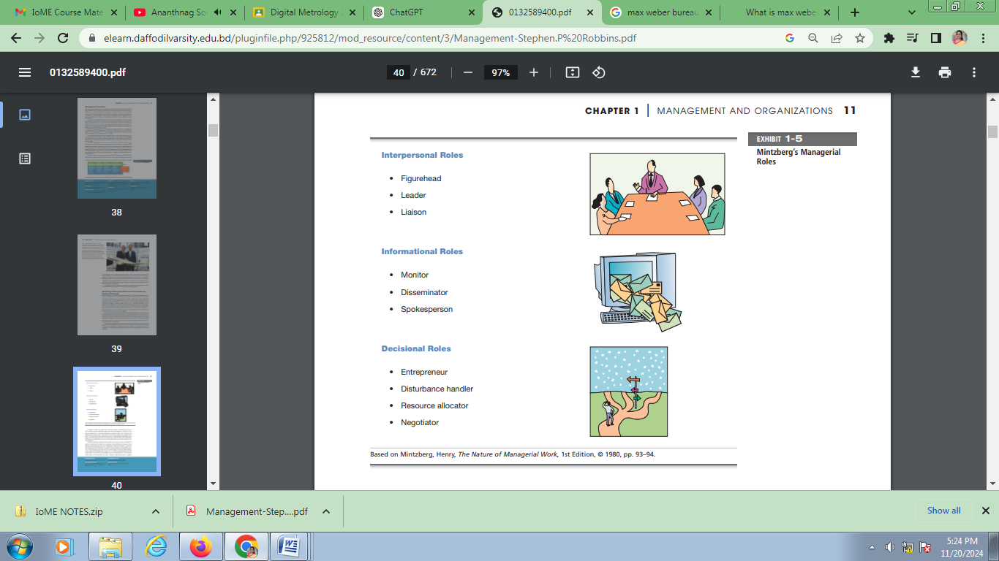

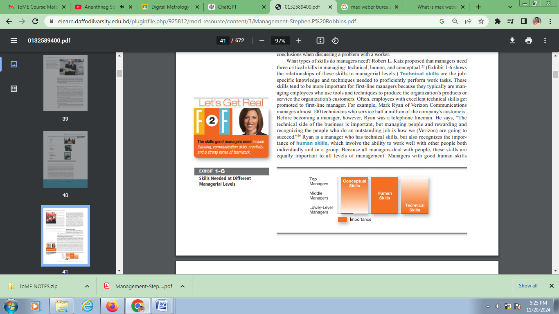

Technical skills are the job specific knowledge and techniques needed to proficiently perform work tasks. These skills tend to be more important for first-line managers because they typically are managing employees who use tools and techniques to produce the organization’s products or service the organization’s customers. Often, employees with excellent technical skills get promoted to first-line manager. For example, Mark Ryan of Verizon Communications manages almost 100 technicians who service half a million of the company’s customers. Before becoming a manager, however, Ryan was a telephone lineman. He says, “The technical side of the business is important, but managing people and rewarding and recognizing the people who do an outstanding job is how we (Verizon) are going to succeed.”26 Ryan is a manager who has technical skills, but also recognizes the importance of human skills, which involve the ability to work well with other people both individually and in a group. Because all managers deal with people, these skills are equally important to all levels of management. Managers with good human skills get the best out of their people. They know how to communicate, motivate, lead, and inspire enthusiasm and trust. Finally, conceptual skills are the skills managers use to think and to conceptualize about abstract and complex situations. Using these skills, managers see the organization as a whole, understand the relationships among various subunits, and visualize how the organization fits into its broader environment. These skills are most important to top managers. Other important managerial skills that have been identified are listed in Exhibit 1-7.

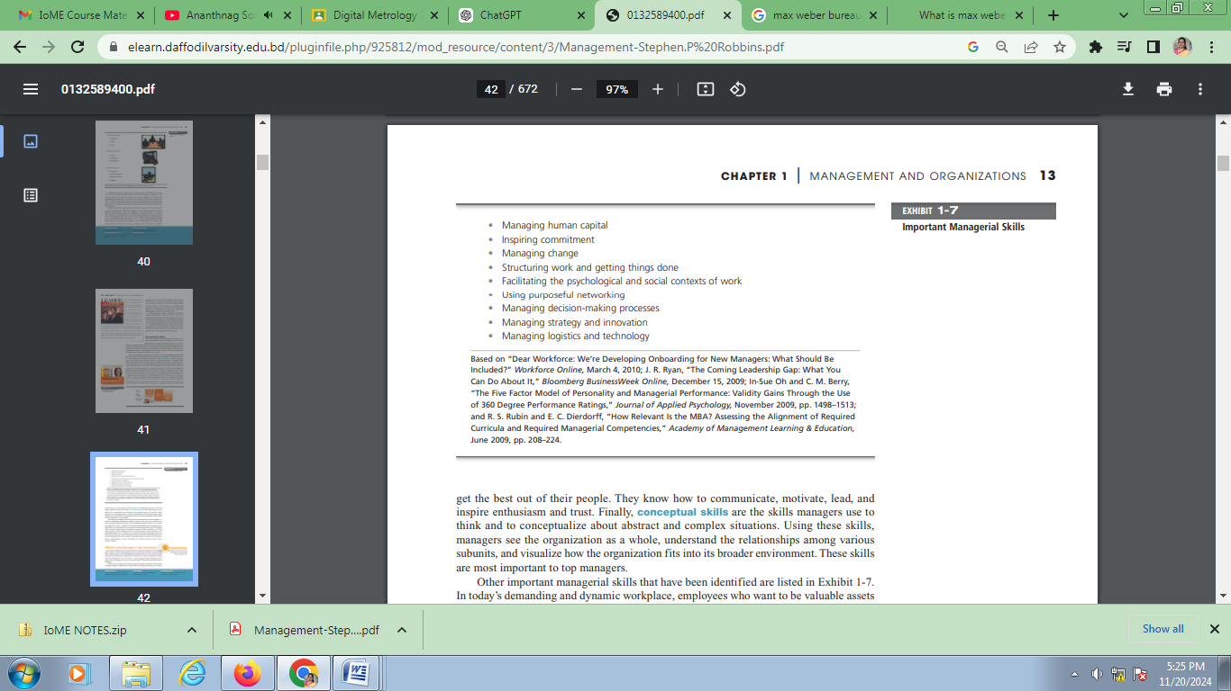

In today’s demanding and dynamic workplace, employees who want to be valuable assets must constantly upgrade their skills, and developing management skills can be particularly beneficial in today’s workplace. We feel that understanding and developing management skills is so important that we’ve included a skills feature at the end of each chapter. (The one in this chapter looks at developing your political skill.) In addition, you’ll find other material on skill building as well as several interactive skills exercises in our my management lab. As you study the four management functions throughout the rest of the book, you’ll be able to start developing some key management skills. Although a simple skill-building exercise won’t make you an instant expert, it can provide you an introductory understanding of some of the skills you’ll need to master in order to be an effective manager.

How Is the Manager’s Job Changing?
“At Best Buy’s headquarters, more than 60 percent of the 4,000 employees are now judged only on tasks or results. Salaried people put in as much time as it takes to do their work. Those employees report better relationships with family and friends, more company loyalty, and more focus and energy. Productivity has increased by 35 percent. Employees say they don’t know whether they work fewer hours—they’ve stopped counting. Perhaps more important, they’re finding new ways to become efficient.”27 Welcome to the new world of managing! In today’s world, managers are dealing with global economic and political uncertainties, changing workplaces, ethical issues, security threats, and changing technology. For example,

Dave Maney, the top manager of Headwaters MB, a Denver-based investment bank, had to fashion a new game plan during the recession. When the company’s board of directors gave senior management complete freedom to ensure the company’s survival, they made a bold move. All but seven key employees were laid off. Although this doesn’t sound very responsible or resourceful, it invited those laid off employees to form independent member firms.

Now, Headwaters steers investment transactions to those firms, while keeping a small percentage for itself. The “restructuring drastically reduced fixed costs and also freed management to do more marketing, rather than day-to-day investment banking transactions.” As Maney said, “It was a good strategy for us and positioned us for the future.”28 It’s likely that more managers will have to manage under such demanding circumstances, and the fact is that how managers manage is changing. Exhibit 1 8 shows some of the most important changes facing managers. Throughout the rest of this book, we’ll be discussing these and other changes and how they’re affecting the way managers plan, organize, lead, and control. We want to highlight three of these changes: the increasing importance of customers, innovation, and sustainability.

Importance of Customers to the Manager’s Job
John Chambers, CEO of Cisco Systems, likes to listen to voice mails forwarded to him from dissatisfied customers. He says, “E-mail would be more efficient, but I want to hear the emotion, I want to hear the frustration, I want to hear the caller’s level of comfort with the strategy we’re employing. I can’t get that through e-mail.”29 This manager understands the importance of customers. You need customers. Without them, most organizations would cease to exist. Yet, focusing on the customer has long been thought to be the responsibility of marketing types. “Let the marketers worry about the customers” is how many managers felt. We’re discovering, however, that employee attitudes and behaviors play a big role in customer satisfaction. For instance, passengers of Qantas Airways were asked to rate their “essential needs” in air travel. Almost every factor listed was one directly influenced by the actions of company employees—from prompt baggage delivery, to courteous and efficient cabin crews, to assistance with connections, to quick and friendly check-ins.

Why Study Management?
You may be wondering why you need to study management. If you’re majoring in accounting or marketing or any field other than management, you may not understand how studying management is going to help you in your career. We can explain the value of studying management by looking at three things: the universality of management, the reality of work, and the rewards and challenges of being a manager.

Management is universally needed in all organizations, so we want to find ways to improve the way organizations are managed. Why? Because we interact with organizations every single day. Are you frustrated when you have to spend two hours in a state government office to get your driver’s license renewed? Are you irritated when none of the salespeople in a retail store seems interested in helping you? Is it annoying when you call an airline three times and customer sales representatives quote you three different prices for the same trip? These examples show problems created by poor management. Organizations that are well managed—and we’ll share many examples of these throughout the text— develop a loyal customer base, grow, and prosper, even during challenging times. Those that are poorly managed find themselves losing customers and revenues. By studying management, you’ll be able to recognize poor management and work to get it corrected. In addition, you’ll be able to recognize and support good management, whether it’s in an organization with which you’re simply interacting or whether it’s in an organization in which you’re employed.

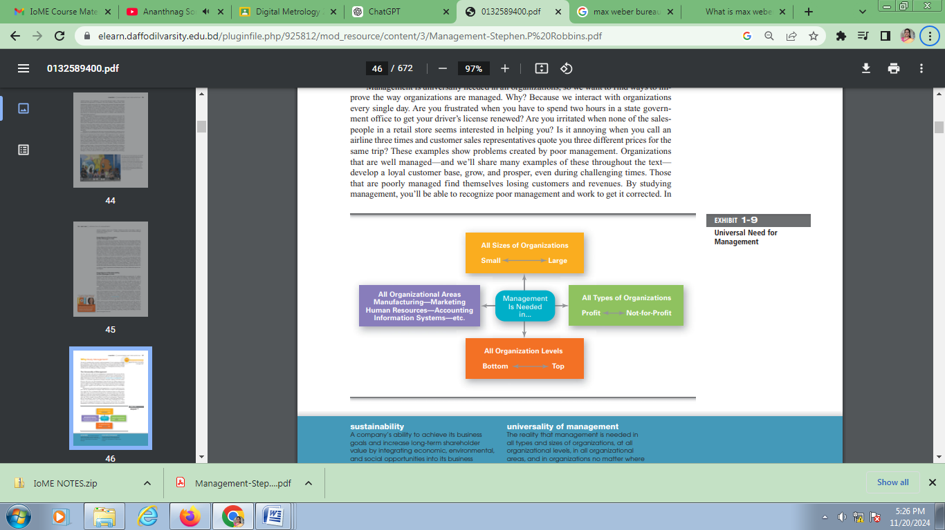

Rewards and Challenges of Being a Manager

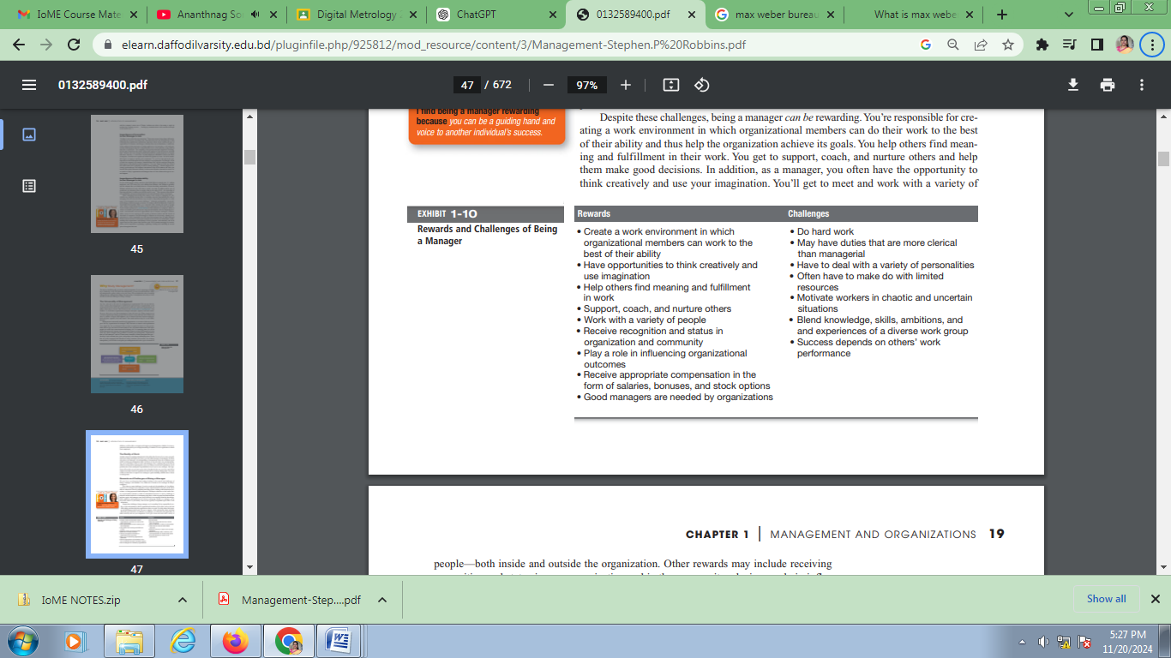

Early Management
Management has been practiced a long time. Organized endeavors directed by people responsible for planning, organizing, leading, and controlling activities have existed for thousands of years. The Egyptian pyramids and the Great Wall of China are proof that projects of tremendous scope, employing tens of thousands of people, were completed in ancient times.1 It took more than 100,000 workers some 20 years to construct a single pyramid. Who told each worker what to do? Who ensured that there would be enough stones at the site to keep workers busy? The answer is managers. Someone had to plan what was to be done, organize people and materials to do it, make sure those workers got the work done, and impose some controls to ensure that everything was done as planned.
Another example of early management can be found in the city of Venice, which was a major economic and trade center in the 1400s. The Venetians developed an early form of business enterprise and engaged in many activities common to today’s organizations. For instance, at the arsenal of Venice, warships were floated along the canals, and at each stop, materials and riggings were added to the ship.2 Sounds a lot like a car “floating” along an assembly line, doesn’t it? In addition, the Venetians used warehouse and inventory systems to keep track of materials, human resource management functions to manage the labor force (including wine breaks), and an accounting system to keep track of revenues and costs.
In 1776, Adam Smith published The Wealth of Nations, in which he argued the economic advantages that organizations and society would gain from the division of labor (or job specialization)—that is, breaking down jobs into narrow and repetitive tasks. Using the pin industry as an example, Smith claimed that 10 individuals, each doing a specialized task, could produce about 48,000 pins a day among them. However, if each person worked alone performing each task separately, it would be quite an accomplishment to produce even 10 pins a day! Smith concluded that division of labor increased productivity by increasing each worker’s skill and dexterity, saving time lost in changing tasks, and creating laborsaving inventions and machinery. Job specialization continues to be popular. For example, think of the specialized tasks performed by members of a hospital surgery team, meal preparation tasks done by workers in restaurant kitchens, or positions played by players on a football team.
Starting in the late eighteenth century when machine power was substituted for human power, a point in history known as the industrial revolution, it became more economical to manufacture goods in factories rather than at home. These large efficient factories needed someone to forecast demand, ensure that enough material was on hand to make products, assign tasks to people, direct daily activities, and so forth. That “someone” was a manager: These managers would need formal theories to guide them in running these large organizations. It wasn’t until the early 1900s, however, that the first steps toward developing such theories were taken.
In this module, we’ll look at four major approaches to management theory: classical, behavioral, quantitative, and contemporary. (See Exhibit MH-1.) Keep in mind that each approach is concerned with trying to explain management from the perspective of what was important at that time in history and the backgrounds and interests of the researchers. Each of the four approaches contributes to our overall understanding of management, but each is also a limited view of what it is and how to best practice it.
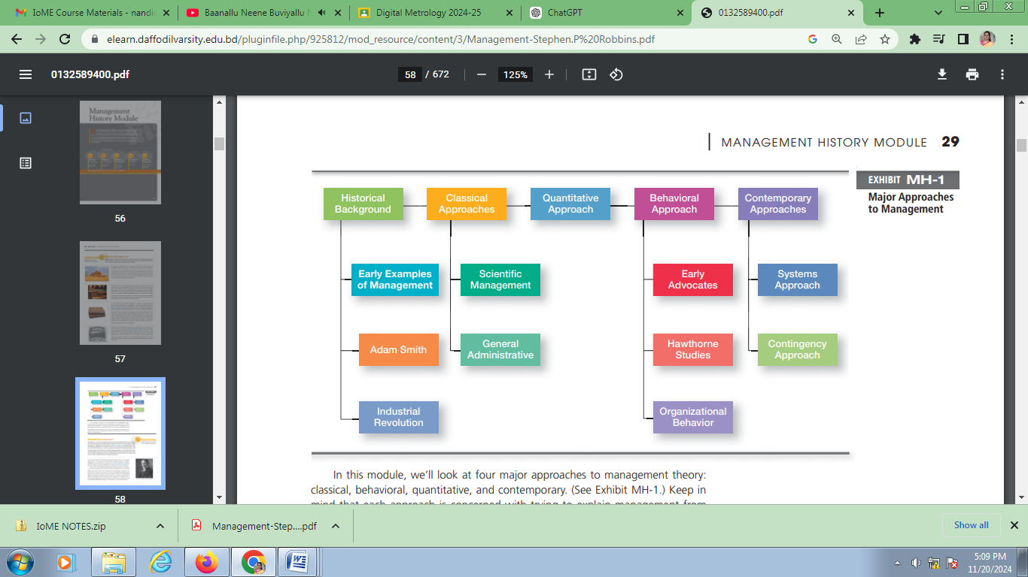

Classical Approach
Although we’ve seen how management has been used in organized efforts since early history, the formal study of management didn’t begin until early in the twentieth century. These first studies of management, often called the classical approach, emphasized rationality and making organizations and workers as efficient as possible. Two major theories comprise the classical approach: scientific management and general administrative theory. The two most important contributors to scientific management theory were Frederick W. Taylor and the husband-wife team of Frank and Lillian Gilbreth. The two most important contributors to general administrative theory were Henri Fayol and Max Weber. Let’s take a look at each of these important figures in management history
If you had to pinpoint when modern management theory was born, 1911 might be a good choice. That was when Frederick Winslow Taylor’s Principles of Scientific Management was published. Its contents were widely embraced by managers around the world. Taylor’s book described the theory of scientific management: the use of scientific methods to define the “one best way” for a job to be done. Taylor worked at the Midvale and Bethlehem Steel Companies in Pennsylvania. As a mechanical engineer with a Quaker and Puritan background, he was continually appalled by workers’ inefficiencies. Employees used vastly different techniques to do the same job. They often “took it easy” on the job, and Taylor believed that worker output was only about one-third of what was possible. Virtually no work standards existed and workers were placed in jobs with little or no concern for matching their abilities and aptitudes with the tasks they were required to do. Taylor set out to remedy that by applying the scientific method to shop-floor jobs. He spent more than two decades passionately pursuing the “one best way” for such jobs to be done.
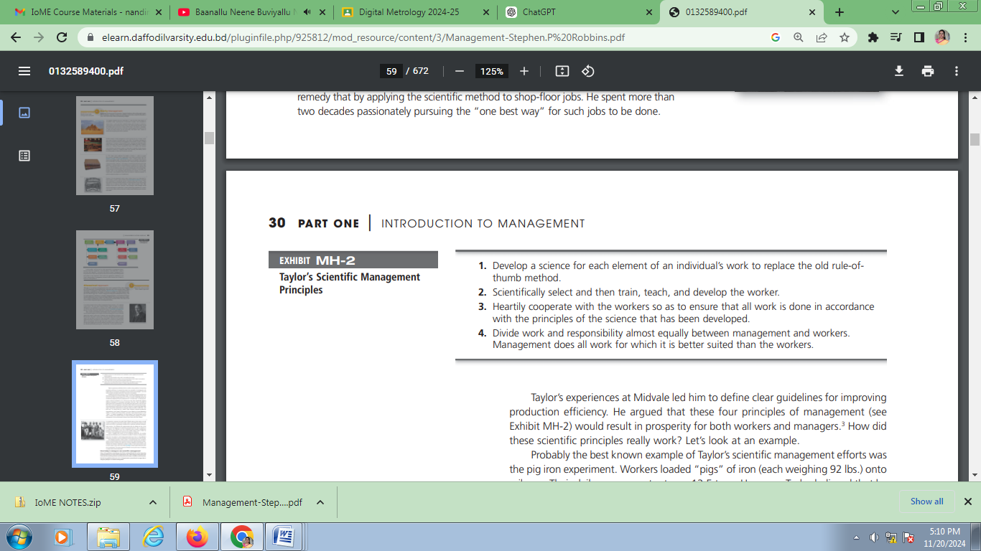
Taylor’s experiences at Midvale led him to define clear guidelines for improving production efficiency. He argued that these four principles of management (see Exhibit MH-2) would result in prosperity for both workers and managers.3 How did these scientific principles really work? Let’s look at an example. Probably the best known example of Taylor’s scientific management efforts was the pig iron experiment. Workers loaded “pigs” of iron (each weighing 92 lbs.) onto rail cars. Their daily average output was 12.5 tons. However, Taylor believed that by scientifically analyzing the job to determine the “one best way” to load pig iron, output could be increased to 47 or 48 tons per day. After scientifically applying different combinations of procedures, techniques, and tools, Taylor succeeded in getting that level of productivity. How? By putting the right person on the job with the correct tools and equipment, having the worker follow his instructions exactly, and motivating the worker with an economic incentive of a significantly higher daily wage. Using similar approaches for other jobs, Taylor was able to define the “one best way” for doing each job. Overall, Taylor achieved consistent productivity improvements in the range of 200 percent or more. Based on his groundbreaking studies of manual work using scientific principles, Taylor became known as the “father” of scientific management. His ideas spread in the United States and to other countries and inspired others to study and develop methods of scientific management. His most prominent followers were Frank and Lillian Gilbreth.
A construction contractor by trade, Frank Gilbreth gave up that career to study scientific management after hearing Taylor speak at a professional meeting. Frank and his wife Lillian, a psychologist, studied work to eliminate inefficient hand-andbody motions. The Gilbreths also experimented with the design and use of the proper tools and equipment for optimizing work performance.4 Also, as parents of 12 children, the Gilbreths ran their household using scientific management principles and techniques. In fact, two of their children wrote a book, Cheaper by the Dozen, which described life with the two masters of efficiency. Frank is probably best known for his bricklaying experiments. By carefully analyzing the bricklayer’s job, he reduced the number of motions in laying exterior brick from 18 to about 5, and in laying interior brick from 18 to 2. Using Gilbreth’s techniques, a bricklayer was more productive and less fatigued at the end of the day. The Gilbreths invented a device called a microchronometer that recorded a worker’s hand-and-body motions and the amount of time spent doing each motion. Wasted motions missed by the naked eye could be identified and eliminated. The Gilbreths also devised a classification scheme to label 17 basic hand motions (such as search, grasp, hold), which they called therbligs (Gilbreth spelled backward with the th transposed). This scheme gave the Gilbreths a more precise way of analyzing a worker’s exact hand movements.

How today’s managers use scientific management
Many of the guidelines and techniques that Taylor and the Gilbreths devised for improving production efficiency are still used in organizations today. When managers analyze the basic work tasks that must be performed, use time-and-motion study to eliminate wasted motions, hire the best-qualified workers for a job, or design incentive systems based on output, they’re using the principles of scientific management.

General administrative theory focused more on what managers do and what constituted good management practice. We introduced Henri Fayol in Chapter 1 because he first identified five functions that managers perform: planning, organizing, commanding, coordinating, and controlling.5 Fayol wrote during the same time period as Taylor. While Taylor was concerned with first-line managers and the scientific method, Fayol’s attention was directed at the activities of all managers. He wrote from his personal experience as the managing director of a large French coal-mining firm. Fayol described the practice of management as something distinct from accounting, finance, production, distribution, and other typical business functions. His belief that management was an activity common to all business endeavors, government, and even the home led him to develop

14 principles of management—fundamental rules of management that could be applied to allorganizational situations and taught in schools. These principles are shown in Exhibit MH-3.
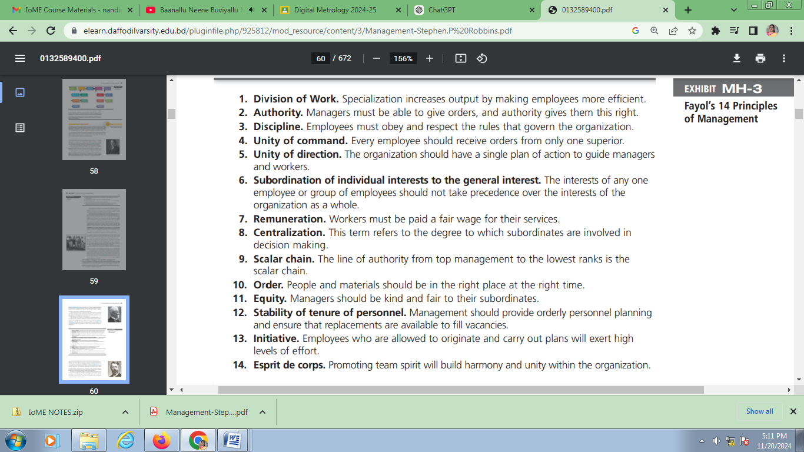
Weber (pronounced VAY-ber) was a German sociologist who studied organizations. Writing in the early 1900s, he developed a theory of authority structures and relations based on an ideal type of organization he called a bureaucracy—a form of organization characterized by division of labor, a clearly defined hierarchy, detailed rules and regulations, and impersonal relationships. (See Exhibit MH-4.) Weber recognized that this “ideal bureaucracy” didn’t exist in reality. Instead he intended it as a basis for theorizing about how work could be done in large groups. His theory became the structural design for many of today’s large organizations. Bureaucracy, as described by Weber, is a lot like scientific management in its ideology. Both emphasized rationality, predictability, impersonality, technical competence, and authoritarianism. Although Weber’s ideas were less practical than Taylor’s, the fact that his “ideal type” still describes many contemporary organizations attests to their importance.
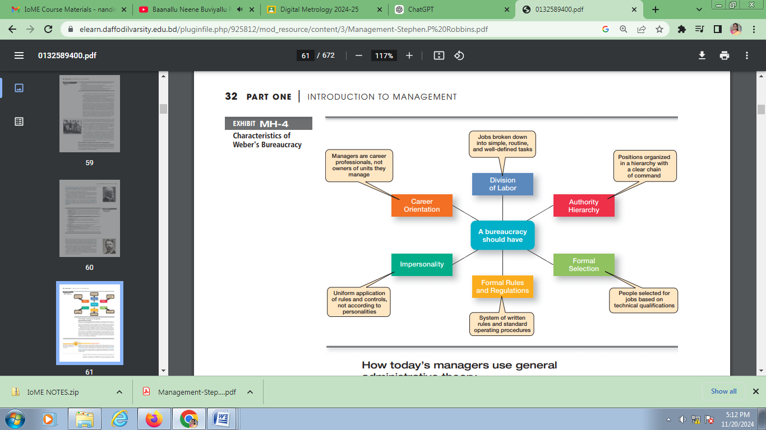
How today’s managers use general administrative theory
Several of our current management ideas and practices can be directly traced to the contributions of general administrative theory. For instance, the functional view of the manager’s job can be attributed to Fayol. In addition, his 14 principles serve as a frame of reference from which many current management concepts—such as managerial authority, centralized decision making, reporting to only one boss, and so forth—have evolved.
Weber’s bureaucracy was an attempt to formulate an ideal prototype for organizations.
Although many characteristics of Weber’s bureaucracy are still evident in large organizations, his model isn’t as popular today as it was in the twentieth century. Many managers feel that a bureaucratic structure hinders individual employees’ creativity
and limits an organization’s ability to respond quickly to an increasingly dynamic environment. However, even in flexible organizations of creative professionals such as Microsoft, Samsung, General Electric, or Cisco Systems—some bureaucratic mechanisms are necessary to ensure that resources are used efficiently and effectively.

Behavioral Approach
As we know, managers get things done by working with people. This explains why some writers have chosen to look at management by focusing on the organization’s people. The field of study that researches the actions (behavior) of people at work is called organizational behavior (OB). Much of what managers do today when managing people—motivating, leading, building trust, working with a team, managing conflict, and so forth—has come out of OB research.
Although a number of individuals in the early twentieth century recognized the importance of people to an organization’s success, four stand out as early advocates of the OB approach: Robert Owen, Hugo Munsterberg, Mary Parker Follett, and Chester Barnard. Their contributions were varied and distinct, yet all believed that people were the most important asset of the organization and should be managed accordingly. Their ideas provided the foundation for such management practices as employee selection procedures, motivation programs, and work teams. Exhibit MH-5 summarizes each individual’s most important ideas.
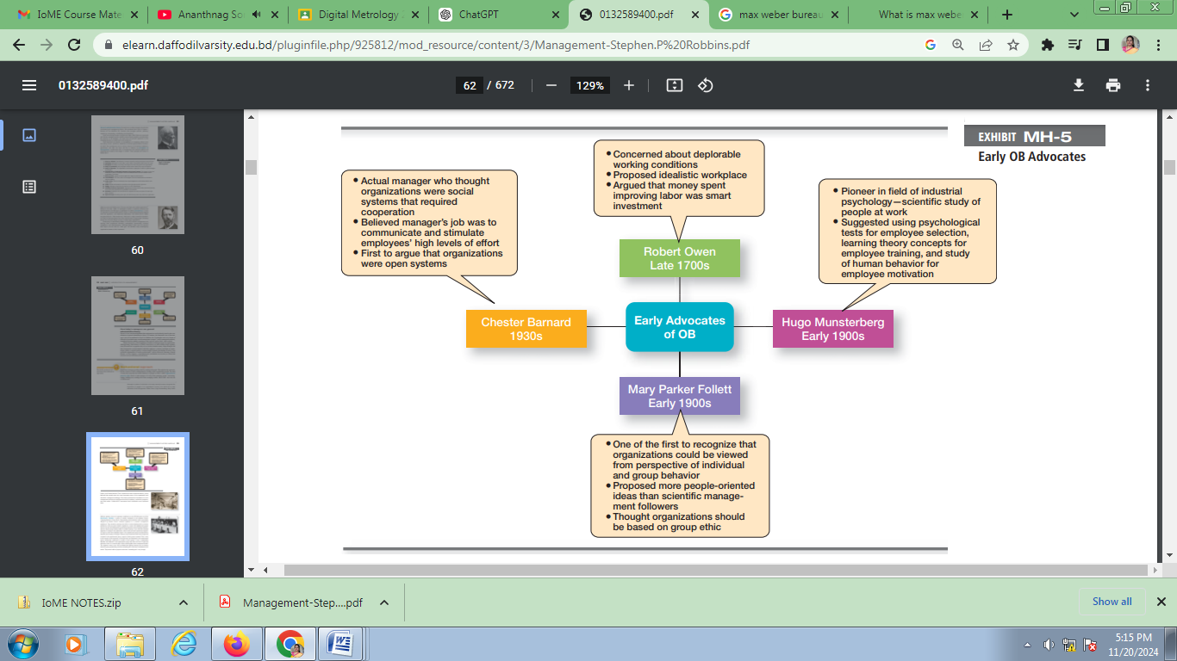
Hawthorne Studies, a series of studies conducted at the Western Electric Company Works in Cicero, Illinois. These studies, which started in 1924, were initially designed by Western Electric industrial engineers as a scientific management experiment. They wanted to examine the effect of various lighting levels on worker productivity. Like any good scientific experiment, control and experimental groups were set up with the experimental group being exposed to various lighting intensities, and the control group working under a constant intensity. If you were the industrial engineers in charge of this experiment, what would you have expected to happen? It’s logical to think that individual output in the experimental group would be directly related to the intensity of the light. However, they found that as the level of light was increased in the experimental group, output for both groups increased. Then, much to the surprise of the engineers, as the light level was decreased in the experimental group, productivity continued to increase in both groups. In fact, a productivity decrease was observed in the experimental group only when the level of light was reduced to that of a moonlit night. What would explain these unexpected results? The engineers weren’t sure, but concluded that lighting intensity was not directly related to group productivity, and that something else must have contributed to the results. They weren’t able to pinpoint what that “something else” was, though.

In 1927, the Western Electric engineers asked Harvard professor Elton Mayo and his associates to join the study as consultants. Thus began a relationship that would last through 1932 and encompass numerous experiments in the redesign of jobs, changes in workday and workweek length, introduction of rest periods, and individual versus group wage plans.7 For example, one experiment was designed to evaluate the effect of a group piecework incentive pay system on group productivity. The results indicated that the incentive plan had less effect on a worker’s output than did group pressure, acceptance, and security. The researchers concluded that social norms or group standards were the key determinants of individual work behavior. Scholars generally agree that the Hawthorne Studies had a game-changing impact on management beliefs about the role of people in organizations. Mayo concluded that people’s behavior and attitudes are closely related, that group factors significantly affect individual behavior, that group standards establish individual worker output, and that money is less a factor in determining output than are group standards, group attitudes, and security. These conclusions led to a new emphasis on the human behavior factor in the management of organizations. Although critics attacked the research procedures, analyses of findings, and conclusions, it’s of little importance from a historical perspective whether the Hawthorne Studies were academically sound or their conclusions justified.8 What is important is that they stimulated an interest in human behavior in organizations.

How today’s managers use the behavioral approach

The behavioral approach has largely shaped how today’s organizations are managed. From the way that managers design jobs to the way that they work with employee teams to the way that they communicate, we see elements of the behavioral approach. Much of what the early OB advocates proposed and the conclusions from the Hawthorne studies have provided the foundation for our current theories of motivation, leadership, group behavior and development, and numerous other behavioral approaches.

Quantitative Approach
Although passengers bumping into each other when trying to find their seats on an airplane can be a mild annoyance for them, it’s a bigger problem for airlines because lines get backed up, slowing down how quickly the plane can get back in the air. Based on research in space time geometry, one airline innovated a unique boarding process called “reverse pyramid” that has saved at least 2 minutes in boarding time.9 This is an example of the quantitative approach, which is the use of quantitative techniques to improve decision making. This approach also is known as management science.

The quantitative approach evolved from mathematical and statistical solutions developed for military problems during World War II. After the war was over, many of these techniques used for military problems were applied to businesses. For example, one group of military officers, nicknamed the Whiz Kids, joined Ford Motor Company in the mid-1940s and immediately began using statistical methods and quantitative models to improve decision making. What exactly does the quantitative approach do? It involves applying statistics, optimization models, information models, computer simulations, and other quantitative techniques to management activities. Linear programming, for instance, is a technique that managers use to improve resource allocation decisions. Work scheduling can be more efficient as a result of critical-path scheduling analysis. The economic order quantity model helps managers determine optimum inventory levels.
Each of these is an example of quantitative techniques being applied to improve managerial decision making. Another area where quantitative techniques are used frequently is in total quality management.
A quality revolution swept through both the business and public sectors in the 1980s and 1990s.10 It was inspired by a small group of quality experts, the most famous being W. Edwards Deming (pictured at right) and Joseph M. Juran. The ideas and techniques they advocated in the 1950s had few supporters in the United States but were enthusiastically embraced by Japanese organizations. As Japanese manufacturers began beating U.S. competitors in quality comparisons, however, Western managers soon took a more serious look at Deming’s and Juran’s ideas . . . ideas that became the basis for today’s quality management programs. Total quality management, or TQM, is a management philosophy devoted to continual improvement and responding to customer needs and expectations. (See Exhibit MH-6.) The term customer includes anyone who interacts with the organization’s product or services internally or externally. It encompasses employees and suppliers as well as the people who purchase the organization’s goods or services. Continual improvement isn’t possible without accurate measurements, which require statistical techniques that measure every critical variable in the organization’s work processes. These measurements are compared against standards to identify and correct problems.

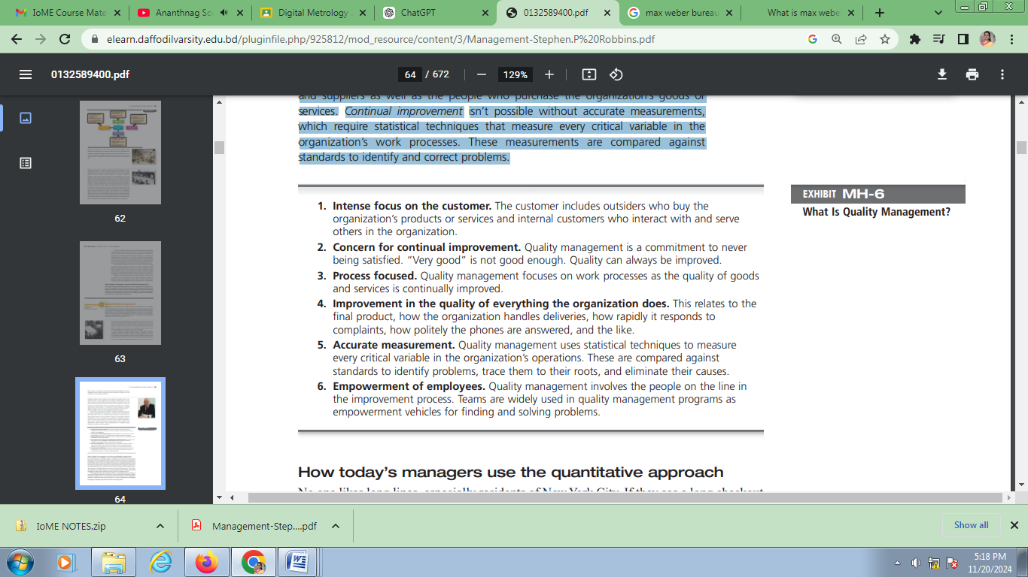

How today’s managers use the quantitative approach No one likes long lines, especially residents of New York City. If they see a long checkout line, they often go somewhere else. However, at Whole Foods’ first gourmet supermarkets in Manhattan, customers found something different—that is, the longer the line, the shorter the wait. When ready to check out, customers are guided into serpentine single lines that feed into numerous checkout lanes. Whole Foods, widely known for its organic food selections, can charge premium prices, which allow it the luxury of staffing all those checkout lanes. And customers are finding that their wait times are shorter than expected.11 The science of keeping lines moving is known as queue management. And for Whole Foods, this quantitative technique has translated into strong sales at its Manhattan stores. The quantitative approach contributes directly to management decision making in the areas of planning and control. For instance, when managers make budgeting, queuing, scheduling, quality control, and similar decisions, they typically rely on quantitative techniques. Specialized software has made the use of these techniques less intimidating for managers, although many still feel anxious about using them.

Contemporary Approaches
As we’ve seen, many elements of the earlier approaches to management theory continue to influence how managers manage. Most of these earlier approaches focused on managers’concerns inside the organization. Starting in the 1960s, management researchers began to look at what was happening in the external environment outside the boundaries of the organization. Two contemporary management perspectives—systems and contingency—are part of this approach.

Systems theory is a basic theory in the physical sciences, but had never been applied to organized human efforts. In 1938, Chester Barnard, a telephone company executive, first wrote in his book, The Functions of an Executive, that an organization functioned as a cooperative system. However, it wasn’t until the 1960s that management researchers began to look more carefully at systems theory and how it related to organizations. A system is a set of interrelated and interdependent parts arranged in a manner that produces a unified whole. The two basic types of systems are closed and open. Closed systems are not influenced by and do not interact with their environment.
In contrast, open systems are influenced by and do interact with their environment. Today, when we describe organizations as systems, we mean open systems. Exhibit MH-7 shows a diagram of an organization from an open systems perspective. As you can see, an organization takes in inputs (resources) from the environment and transforms or processes these resources into outputs that are distributed into the environment. The organization is “open” to and interacts with its environment.
How does the systems approach contribute to our understanding of management? Researchers envisioned an organization as
being made up of “interdependent factors, including individuals, groups, attitudes, motives, formal structure,
interactions, goals, status, and authority.”12 What this means is that as managers coordinate work activities in the various parts
of the organization, they ensure that all these parts are working together so the organization’s goals can be achieved. For
example, the systems approach recognizes that, no matter how efficient the production department might be, the marketing department must anticipate changes in customer tastes and work with the product development department in creating products customers want or the organization’s overall performance will suffer.

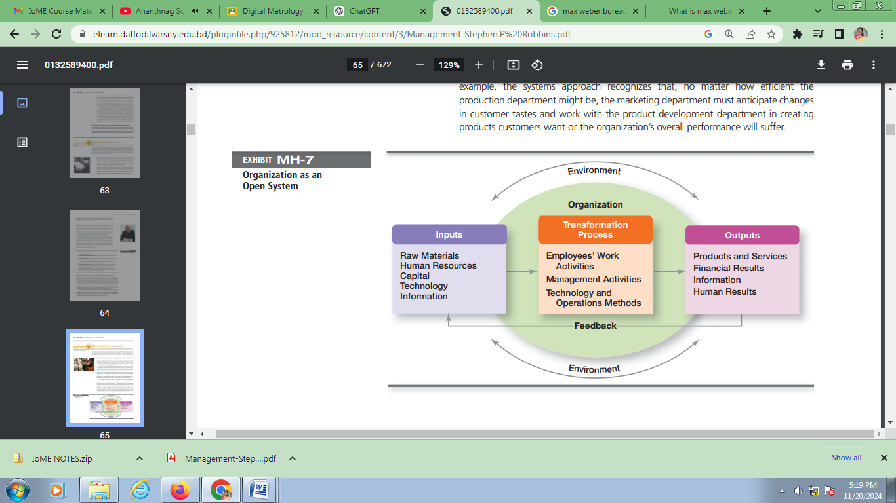
In addition, the systems approach implies that decisions and actions in one organizational area will affect other areas. For example, if the purchasing department doesn’t acquire the right quantity and quality of inputs, the production department won’t be able to do its job. Finally, the systems approach recognizes that organizations are not selfcontained. They rely on their environment for essential inputs and as outlets to absorb their outputs. No organization can survive for long if it ignores government regulations, supplier relations, or the varied external constituencies upon which it depends. How relevant is the systems approach to management? Quite relevant. Consider, for example, a shift manager at a Starbucks restaurant who must coordinate the work of employees filling customer orders at the front counter and the drive-through windows, direct the delivery and unloading of food supplies, and address any customer concerns that come up. This manager “manages” all parts of the “system” so that the restaurant meets its daily sales goals.
The early management theorists came up with management principles that they generally assumed to be universally applicable. Later research found exceptions to many of these principles. For example, division of labor is valuable and widely used, but jobs can become too specialized. Bureaucracy is desirable in many situations, but in other circumstances, other structural designs are more effective. Management is not (and cannot be) based on simplistic principles to be applied in all situations. Different and changing situations require managers to use different approaches and techniques. The contingency approach (sometimes called the situational approach) says that organizations are different, face different situations (contingencies), and require different ways of managing. A good way to describe contingency is “if, then.” If this is the way my situation is, then this is the best way for me to manage in this situation. It’s intuitively logical because organizations and even units within the same organization differ—in size, goals, work activities, and the like. It would be surprising to find universally applicable management rules that would work in all situations. But, of course, it’s one thing to say that the way to manage “depends on the situation” and another to say what the situation is. Management researchers continue working to identify these situational variables. Exhibit MH-8 describes four popular contingency variables. Although the list is by no means comprehensive—more than 100 different variables have been identified—it represents those most widely used and gives you an idea of what we mean by the term contingency variable. The primary value of the contingency approach is that it stresses there are no simplistic or universal rules for managers to follow.
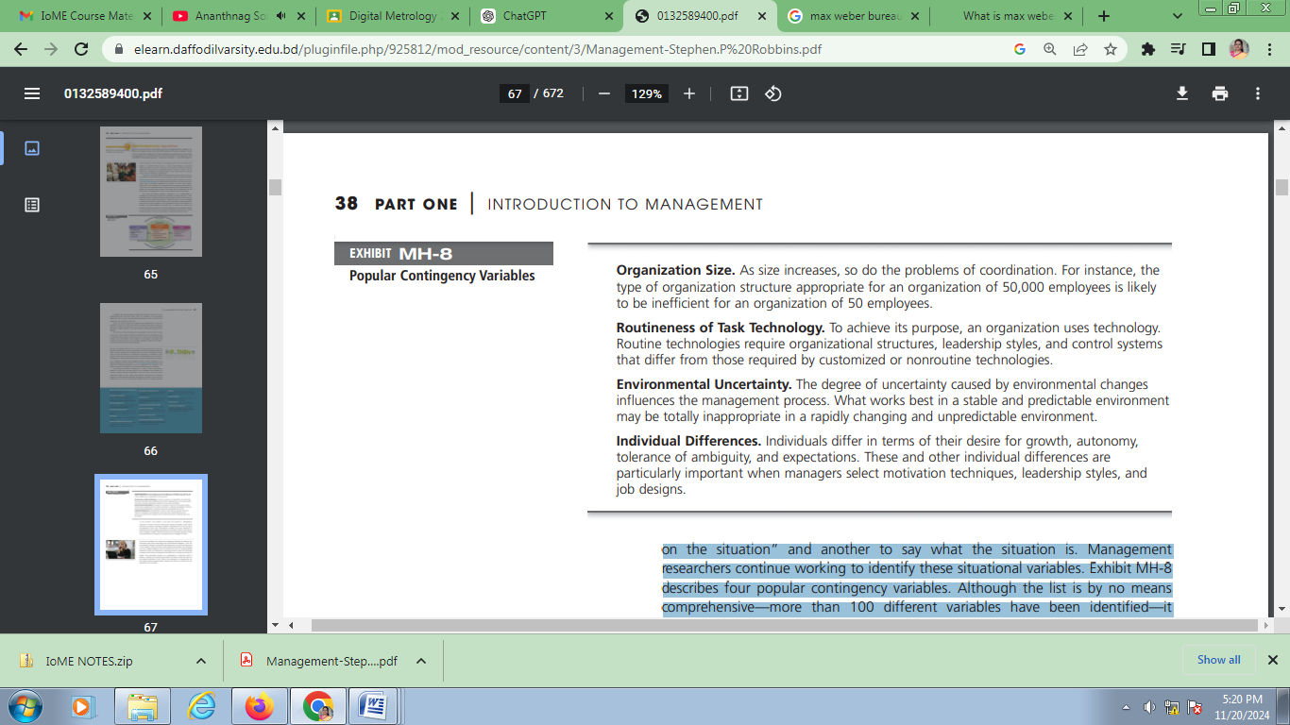

So what do managers face today when managing? Although the dawn of the information age is said to have begun with Samuel Morse’s telegraph in 1837, the most dramatic changes in information technology have occurred in the latter part of the twentieth century and have directly affected the manager’s job. Managers now may manage employees who are working from home or working halfway around the world. An organization’s computing resources used to be mainframe computers locked away in temperature-controlled rooms and only accessed by the experts. Now, practically everyone in an organization is connected—wired or wireless—with devices no larger than the palm of the hand. Just like the impact of the Industrial Revolution in the 1700s on the emergence of management, the information age has brought dramatic changes that continue to influence the way organizations are managed.

CHAPTER SUMMARY
by Learning Outcomes
- Describe some early management examples.
  - Studying history is important because it helps us see the origins of today’s management practices and recognize what has and has not worked. We can see early examples of management practice in the construction of the Egyptian pyramids and in the arsenal of Venice. One important historical event was the publication of Adam Smith’s Wealth of Nations, in which he argued the benefits of division of labor (job specialization). Another was the industrial revolution where it became more economical to manufacture in factories than at home. Managers were needed to manage these factories and these managers needed formal management theories to guide them.

- Explain the various theories in the classical approach.
  - Frederick W. Taylor, known as the “father” of scientific management, studied manual work using scientific principles—that is, guidelines for improving production efficiency—to find the one best way to do those jobs. The Gilbreths’ primary contribution was finding efficient hand-and-body motions and designing proper tools and equipment for optimizing work performance. Fayol believed that the functions of management were common to all business endeavors but also were distinct from other business functions. He developed 14 principles of management from which many current management concepts have evolved. Weber described an ideal type of organization he called a bureaucracy, characteristics that many of today’s large organizations still have. Today’s managers use the concepts of scientific management when they analyze basic work tasks to be performed, use time-and-motion study to eliminate wasted motions, hire the best qualified workers for a job, and design incentive systems based on output. They use general administrative theory when they perform the functions of management and structure their organizations so that resources are used efficiently and effectively.

- Discuss the development and uses of the behavioral approach.
  - The early OB advocates (Robert Owen, Hugo Munsterberg, Mary Parker Follett, and Chester Barnard) contributed various ideas, but all believed that people were the most important asset of the organization and should be managed accordingly. The Hawthorne Studies dramatically affected management beliefs about the role of people in organizations, leading to a new emphasis on the human behavior factor in managing. The behavioral approach has largely shaped how today’s organizations are managed. Many current theories of motivation, leadership, group behavior and development, and other behavioral issues can be traced to the early OB advocates and the conclusions from the Hawthorne Studies.

- Describe the quantitative approach.
  - The quantitative approach involves applications of statistics, optimization models, information models, and computer simulations to management activities. Today’s managers use the quantitative approach, especially when making decisions, as they plan and control work activities such as allocating resources, improving quality, scheduling work, or determining optimum inventory levels. Total quality management—a management philosophy devoted to continual improvement and responding to customer needs and expectations— also makes use of quantitative methods to meet its goals.

- Explain the various theories in the contemporary approach.
  - The systems approach says that an organization takes in inputs (resources) from the environment and transforms or processes these resources into outputs that are distributed into the environment. This approach provides a framework to help managers understand.

